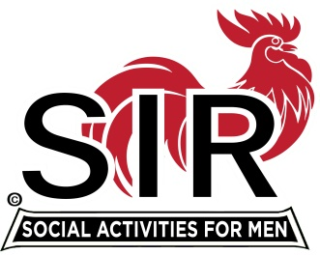
Las Trampas Branch 116
BEC Meeting Agenda
April 19, 2021, 8:30 AM
The Mission of SIR is to enhance the lives of our members through fun activities, events and luncheons – while making friends for life.

8:30 am Call to order; Secretary confirm a quorum

8:35 Secretary –Paul Ramacciotti – Approval of March 15, 2021 minutes

8:40 Treasurer –/Alan Fitzgerald – Report

8:45 Standing Reports
- Membership – Phil Goff
- RAMP Department Head Reports:
- Recruitment
- Activity Coordinator
- Member relations
- Publicity
- Carmel Golf [ Jim Barstow]
- Boundary Oak Restaurant Update [Mike Schneider]

9:00 Big SIR Report – Sam Beret

- April 19 monthly meeting agenda
- State SIR Directives

9:15 Little SIR Report - Fred Wachowicz
1. Speaker:
2. Birthday Boys
3. Diversity Team Report

9:25 Branch website documents - Neil Schmidt

9:30 Old Business
- TBA
New Business:

9:45 Adjourn; Next BEC Meeting, , May 17, 2021

Join Zoom Meeting Weblink
https://us02web.zoom.us/j/85332344422
Meeting ID: 853 3234 4422
Passcode: 612956
Dial by home phone: (669) 900-9128

